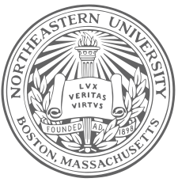

Yanet Canavan

Director of Cultural Activities

# In Recognition of Professional Achievement for Successfully Participating in the Cultural Exchange Program Between Northeastern University

# (Boston, Massachusetts) and the Air Force School, “Jose Quinones” (Lima, Peru). Your Hard Work and Enthusiasm Are Characteristics That Made Possible the Successful Completion of This Program, Held May 26 – 30, 2014

# at IE Jose Abelardo Quinones School.

[Recipient Name]

## Is Awarded To

Certificate of Participation

### As Presented By Northeastern University On This 30th Day of May Two Thousand and Fourteen

Northeastern University Peru Dialogue of Civilization 2014